**Solution architecutre**

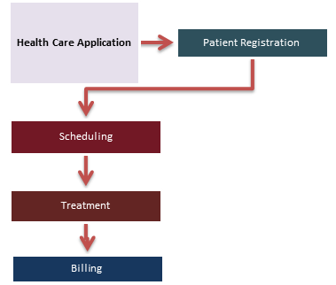

DATA SET

DATA SET

PYTHON EDA

VISALIZATION